|  |  |
| --- | --- |
|  | **Project Design Phase-I** |
|  | **Solution Architecture** |
|  |  |
| Date | 01 October 2022 |
| Team ID | PNT2022TMID33034 |
| Project Name | Fertilizer Recommendation System for Disease |
|  | Prediction |
| Maximum Marks | 4 Marks |
| **Solution Architecture:** |  |

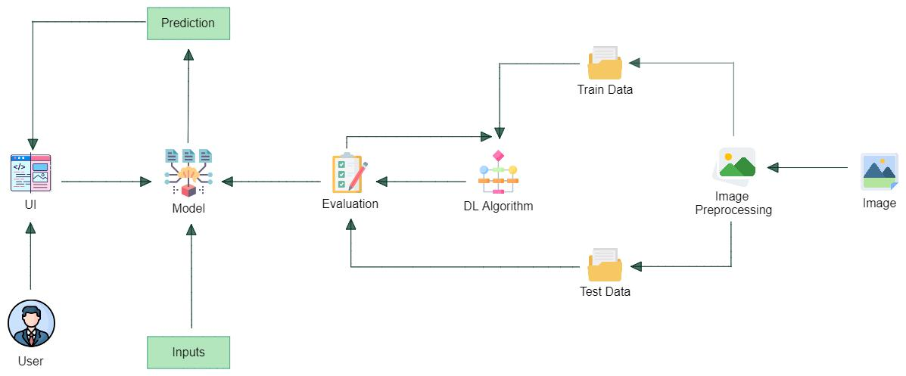

Plant image

Fertilizer recommend engine